**Why Should Outdated Technology Be Recycled?**

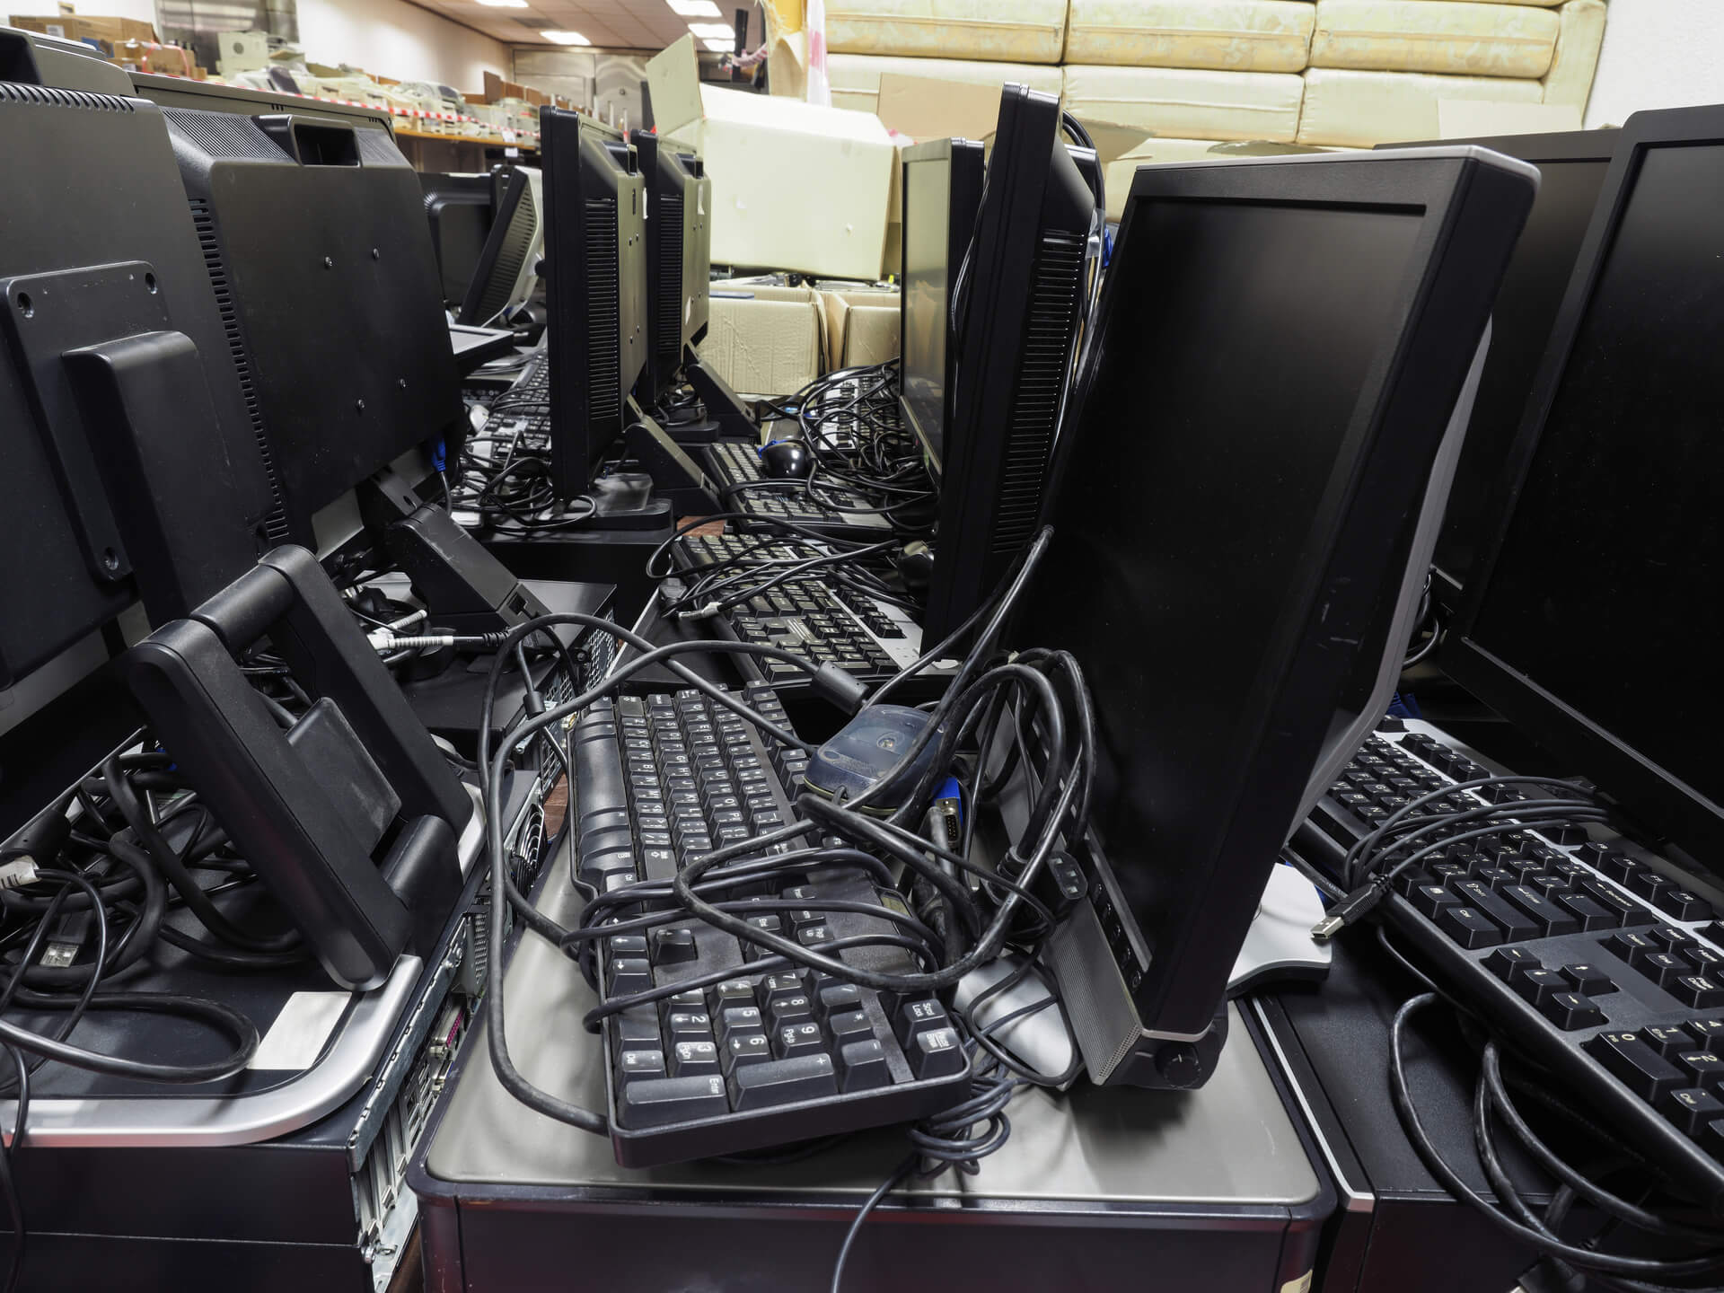

Technology is essential for optimal productivity in the office. Unfortunately, software and equipment can't keep up with the latest developments indefinitely. Technology eventually becomes obsolete, and companies are faced with the choice of updating or becoming obsolete with their older technologies.

Here are some of the primary reasons why you should give in your outmoded equipment to a hardware recycling firm rather than trying to painfully press on if your business is suffering a technological changeover.

**Why Should Outdated Technology Be Recycled?**

Regardless of how connected you are to your old technology, the chances are that once you upgrade to new gear, you will never go back to it.

If you do decide to maintain your old technology for a "rainy day," keep these considerations in mind to avoid costly breaches and other troubles caused by outmoded equipment.

**Security Threats Affecting Older Technology**

Software that isn't up to date in terms of spyware and malware protection leaves the door wide open for costly breaches. Cyber criminals prey on out-of-date software that is still in use, and they can easily obtain vital data that has been left over because your firm chose to save money.

When it's time to upgrade, officially say goodbye to your old computer and give it over to Retire PC's recycling experts. Not only will recycling prevent you from reusing outdated software, but we can also complete thorough data destruction, ensuring that no one will be able to access your old data after you've given it to our recycling team.

**Productivity is hampered by obsolete technology.**

When your technology is running on outdated software, it's only a matter of time until your productivity and profits suffer. Freezes become more often on older equipment, costly repairs and upkeep can eat into your budget, and your system as a whole will run slower.

If you're aware that your equipment is approaching obsolescence, don't cling to the past. Make budgeting decisions that will benefit your business. Recycle your old equipment and transfer effortlessly into the future with new computers and related technology that will keep you competitive in your industry.

**Recycling can assist you in purchasing new equipment.**

Finances might be one of the most common roadblocks to modernising a company's equipment. Allow Retire PC's rewards programme to assist you in making the most money from your retired IT assets.

We make transactions quick and easy so that your employees may put their money toward the equipment that your company need. Reach out to us if you have any questions about the types of equipment we take, and a member of our team will gladly assist you.

**What Is the Best Way to Recycle Older Technology?**

When it comes to recycling, you don't want to contribute to the e-waste problem in your neighbourhood. So, never, ever, ever, ever, ever, ever, ever, ever, ever, ever, ever, ever, ever, ever, ever, ever, ever, ever, ever, ever Thankfully, effective technology recycling is straightforward.

A recycling firm like Retire PC can assist you if you need to recycle a large amount of office equipment.

All your team has to do now is gather the equipment, organise it, and set up a pick-up time. Our crew will handle the rest and come to your location to collect your old gadget.

**Recycle Pro can help you update your office technology in a secure manner.**

[Recycle Pro's](https://www.recyclepro.co.uk/) technology recycling professionals are ready to accept your old office equipment if you're ready to send it out the door. Contact us immediately to learn more about our recycling process and how you can profit from your used equipment right now.